Title | Data Manipulation and Analysis using the Starwars Dataset in R
Problem Statement | Basic Data Manipulation with Pandas: Create a DataFrame with columns  Name, Age, and City containing data for five individuals. Perform the  following operations: select only the Name and Age columns, filter rows  where Age is greater than 25, add a new column Country with a default  value, and sort the DataFrame by Age in descending order. Finally,  calculate the average age of the individuals.
Objectives | - To understand how to create a Pandas DataFrame from a Python  - dictionary.  - To learn column selection techniques using Pandas.  - To apply filtering conditions on DataFrame rows.  - To create and populate new columns in a DataFrame.  - To sort data based on column values.  - To perform basic statistical analysis using Pandas aggregate functions.
Dataset  URL Link /  File | Name Age City  Alice 23 New York  Bob 30 London  Charlie 28 Paris  David 35 Tokyo  Emma 22 Sydney
Functions  Details | Sl. No. | Function | Package | Description of function
 | 1 | DataFrame() | pandas | Creates a DataFrame
 | 2 | sort_values() | pandas | Sorts DataFrame rows
 | 3 | mean() | pandas | Calculates the average value
 | 4 | sort_values() | pandas | Sorts DataFrame rows
Steps/  Process/  Procedure/  Algorithm/  Flowchart/  Model | Step 1  Import the pandas library and create a dictionary containing Name, Age and City Data  Step 2  Convert the dictionary into a pandas DataFrame  Step 3  Select only the Name and Age columns from the DataFrame.  Step 4  Filter the DataFrame to display individuals whose age is greater than 25.  Step 5  Add a new column named Country and assign a default value of India.  Step 6  Sort the DataFrame in descending order based on the Age column.  Step 7  Calculate the average age of all individuals using the mean() function.  Step 8  – Display all intermediate and final results.
Program | # Load Necessary Packages  import pandas as pd  # Step 1: Create Dataset  dataframe1 = {  "Name": ["Alice", "Bob", "Charlie", "David", "Emma"],  "Age": [23, 30, 28, 35, 22],  "City": ["New York", "London", "Paris", "Tokyo", "Sydney"]  }  # Step 2: Create DataFrame  df = pd.DataFrame(dataframe1)  print("Original DataFrame")  print(df)  print()  # Step 3: Select Name and Age Columns  name_age = df[["Name", "Age"]]  print("Name and Age")  print(name_age)  print()  # Step 4: Filter Rows where Age > 25  filtered_df = df[df["Age"] > 25]  print("Age > 25")  print(filtered_df)  print()  # Step 5: Add Country Column  df["Country"] = "India"  print("Country Added")  print(df)  print()  # Step 6: Sort by Age in Descending Order  sorted_df = df.sort_values(by="Age", ascending=False)  print("Sorted Data")  print(sorted_df)  print()  # Step 7: Calculate Mean Age  mean_df = df["Age"].mean()  print("Mean Age")  print(mean_df)
Output Snapshots  With  Explanation/  Observations | 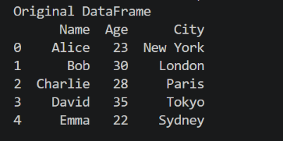  Figure 1.1 displays the original DataFrame created from a Python dictionary containing information about five individuals. The DataFrame consists of three columns: Name, Age, and City, where each row represents a different individual and their corresponding details. The pd.DataFrame() function converts the dictionary data into a structured tabular format, making it easier to store, view, and manipulate data using Pandas. This DataFrame serves as the  Figure 1.1 Original Dataframe  starting dataset for all subsequent operations such as column selection,  filtering, adding new columns, sorting, and calculating statistical  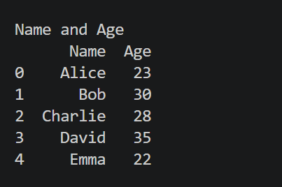  measures.  Figure 1.2 shows the DataFrame after selecting only the Name and Age columns from the original dataset using Pandas column indexing. This operation extracts the required columns and creates a new DataFrame named name_age, removing the City column from the view. Such column selection helps focus on relevant attributes for analysis and reduces unnecessary data processing.  Figure 1.2 Selected Name and Age Columns  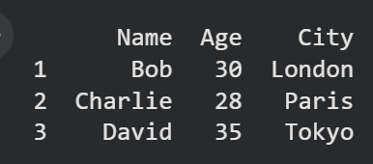  Figure 1.3 presents the filtered  DataFrame containing only those  individuals whose Age is greater  than 25. This filtering operation is  performed using a conditional  expression in Pandas, where the Age column is checked against the condition Age > 25. As a result, only the rows satisfying the condition are retained in the new DataFrame filtered_df.  Figure 1.3: Filtered Data (Age > 25)  Figure 1.3 operation demonstrates how Pandas can be used to extract  specific records based on user-defined criteria, which is a common  requirement in data analysis and data preprocessing tasks.  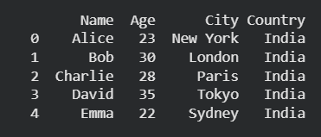  Figure 1.4 displays the  DataFrame after adding a  new column named Country with a default value of "India" for all records. This operation is performed using Pandas column assignment, where the same value is assigned to every row in the newly created column. Adding new columns is a common data transformation technique used to enrich datasets with additional information. Figure 1.4 output confirms that the Country column has been successfully added to the DataFrame, and each individual has been assigned the default value India. The enriched dataset is now ready for further operations such as sorting and statistical analysis.  Figure 1.4: DataFrame with Country Column  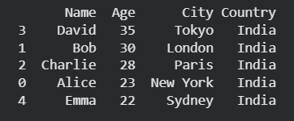  Figure 1.5 illustrates the DataFrame after sorting the records based on the Age column in descending order using the Pandas sort_values() function. In this operation, individuals are arranged from the highest age to the lowest age. Sorting helps organize data systematically and makes it easier to identify records with the largest or smallest values. Figure 1.5 output confirms that the DataFrame has been successfully sorted in descending order of Age, placing the oldest individual at the top and the youngest individual at the bottom. Such sorting operations are commonly used in data analysis to rank, compare, and organize records efficiently.  Figure 1.5 Sorted Data by Age (Descending Order)  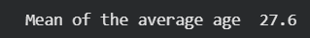  Figure 1.6 presents the average age of all  individuals in the dataset, calculated using  the Pandas mean() function. The average  Figure 1.6 Average Age of Individuals  (mean) age is obtained by summing all the  age values and dividing the total by the  number of individuals in the DataFrame. This operation demonstrates the  use of aggregate statistical functions in Pandas for summarizing  numerical data. Figure 1.6 output confirms that the Pandas mean()  function has successfully computed the average age of the five  individuals as 27.6 years. Such aggregate functions are widely used in  data analysis to summarize and interpret numerical information efficiently.
Conclusions | This experiment successfully demonstrated the use of Pandas for basic data manipulation and analysis. A DataFrame containing the details of five individuals was created using the columns Name, Age, and City. Various DataFrame operations were then performed, including selecting specific columns, filtering rows based on a condition, adding a new column with default values, sorting records, and calculating statistical measures. These operations showcased the flexibility and efficiency of Pandas in handling tabular data.  The results showed that:  • The Name and Age columns could be extracted independently for focused analysis.  • Filtering enabled the identification of individuals whose Age was greater than 25 years.  • A new Country column was successfully added to enrich the dataset.  • Sorting arranged the records in descending order of age, making it easy to identify the oldest and youngest individuals.  • The average age of the individuals was calculated as 27.6 years, demonstrating the use of aggregate functions in data analysis.  Overall, this exercise provided a strong foundation in DataFrame creation, data selection, filtering, transformation, sorting, and statistical analysis using Pandas. These fundamental data manipulation techniques are widely used in Data Science, Machine Learning, Data Analytics, and Business Intelligence applications, making them essential skills for working with real-world datasets.
References | - Michael Freeman and Joel Ross, Programming Skills for Data Science: Start Writing Code to Wrangle, Analyze, and Visualize Data with R, Addison-Wesley, 2018  - Pandas Documentation: https://pandas.pydata.org/docs/  - Python Documentation: https://docs.python.org/3/  - Python Program (Google Colab link /Githab link)  https://colab.research.google.com/drive/1sjdIVacPTNg2JO_nGS8gic99hGEtMuRe?usp=sharing  - Class lecture link  https://drive.google.com/file/d/15diEukCtrPLimox63oa9ce1U-t4qVMUy/view

